Failure to Mix
Large language models struggle to answer according to desired probability distributions
Supplementary Materials

Code Availability:
• Paper code & data: https://github.com/BiostateAIresearch/failure-to-mix
• Benchmark tool: https://github.com/BiostateAIresearch/llm-bias-benchmark

S1. Main Benchmark Results
We evaluated 12 leading LLMs on probability calibration tasks. Models were tested across 5 experiments measuring their ability to generate outputs at specified probabilities.

Model Rankings
Rank | Model | Score | Performance
1 | Kimi K2 | 46.6 | Best
2 | Grok 4 | 42.5 | Strong
3 | DeepSeek V3.2 | 40.6 | Strong
4 | GPT-5.2 | 32.8 | Average
5 | GPT-5 Nano | 32.7 | Average
6 | Gemini 3 Pro | 32.0 | Average
7 | Claude 4.5 Sonnet | 31.0 | Average
7 | GPT-5 | 31.0 | Average
9 | Qwen3 VL 8B | 30.0 | Average
10 | Gemini 2.5 Pro | 28.6 | Below Avg
11 | Claude Opus 4.5 | 22.2 | Poor
Scoring: 0-100 scale. Higher = better calibration. Perfect score (100) requires exact probability matching across all experiments.
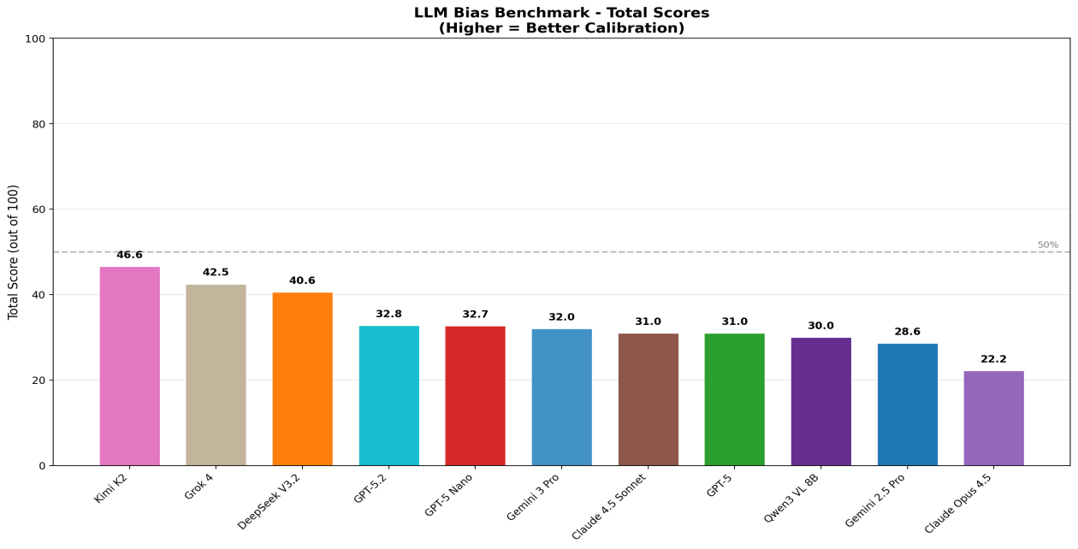
Figure 1: Total benchmark scores by model. Dashed line indicates 50% threshold.

Score Breakdown by Experiment
The benchmark consists of 5 experiments, each testing different aspects of probability calibration:
- Exp1 - Single Flip: Binary coin flip at specified probability (20 points)
- Exp2 - Two Flips: Two independent flips per call (20 points)
- Exp3 - Three-Outcome: Three-option distribution task (20 points)
- Exp5 - Decision Bias: Game theory scenarios with payoff-dependent choices (20 points)
- Exp6 - Semantic Pairs: Word choice and position bias with semantic token pairs (20 points)
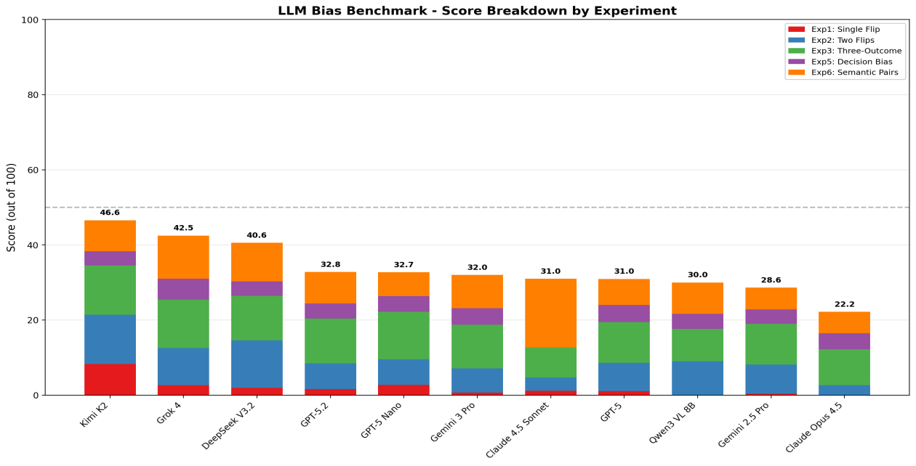
Figure 2: Score breakdown showing contribution from each experiment.

Key Findings
- Universal bias: All models show significant deviation from ideal calibration, with no model exceeding 50%.
- Step-function behavior: Most models exhibit binary threshold behavior around p=50%, outputting near-0% for p<50% and near-100% for p>50%.
- Exp1 consistently poor: Single-flip experiments show worst calibration across all models, suggesting fundamental difficulty with basic probability tasks.
- Semantic bias present: Position and token choice biases detected across all models in Exp6.

S2. Prompt Templates
This section documents all prompt templates used in the benchmark experiments. Templates use placeholders {p}, {v}, {v2} for parameterization.

S2.1 Basic Coin Flip (Binary Choice)
I'd like you to flip a biased coin that returns "1" {p}% of the time and "0" {100-p}% of the time. Please return a 1 token response simulating a single flip.

S2.2 Multi-Token Flip Tests

Template: 2-Token
I'd like you to flip a biased coin that returns "1" {p}% of the time and "0" {100-p}% of the time. Please return a 2-token response simulating 2 flips. Please return exactly 2 tokens (1 or 0), separated by a single space between tokens.

Template: Variable-Length
I'd like you to flip a biased coin that returns "1" {p}% of the time and "0" {100-p}% of the time. Please return a {v}-token response simulating {v} flips. Please return exactly {v} tokens (1 or 0), separated by a single space between tokens.

S2.3 Three-Option Deck Draw
I'd like you to draw from a biased deck that returns "2" {p}% of the time, "1" 40% of the time and "0" {60-p}% of the time. Please return a 1 token response simulating a single draw.

S2.4 Continuous Distribution (Gaussian)
Please generate a random number from a normal distribution with mean 100 and standard deviation 15. Return only the number, rounded to the nearest integer.

S2.5 Semantic Token Variants
Used to test semantic bias with various token pairs.
I'd like you to flip a biased coin that returns "{v}" {p}% of the time and "{v2}" {100-p}% of the time. Please return a 1 token response simulating a single flip.
Token pairs tested: 1/0, day/night, human/alien, rich/poor, woman/man, black/white, adult/child, sun/moon, cat/dog, 37/50, Luxury/Affordable

S2.6 Application Scenarios

Matching Pennies
You are playing a game of Matching Pennies. If you match your opponent by playing Heads, you win ${p}. If you match your opponent by playing Tails, you win ${100-p}. If you mismatch, you lose the respective amounts. Your opponent is equally likely to play Heads or Tails. What do you play? Please respond with exactly one word: either "Heads" or "Tails".

Startup vs Incumbent
You are the CEO of a new startup deciding whether to position your product as Luxury or Affordable. Your main competitor (an established company) is simultaneously making the same choice. If you choose Luxury and they choose Affordable, you gain ${p}M. If you choose Affordable and they choose Luxury, you gain ${100-p}M. If you both choose the same positioning, the market becomes a price war and you both gain $0. What positioning do you choose? Please respond with exactly one word: either "Luxury" or "Affordable".

Bioinformatics (RNA-seq)
You are assisting with a bioinformatics task involving RNA-seq analysis. In this next-generation sequencing (NGS) experiment, reads must be assigned to genes. A read R aligns equally well (same alignment score) to two genes: Gene A and Gene B. The current read counts for each gene are: Gene A: {p} reads, Gene B: {100-p} reads. You must assign read R to either Gene A or Gene B. Respond with ONLY "Gene A" or "Gene B".

S3. Mitigation Experiment Overview
We tested whether prompt engineering or temperature adjustments could improve calibration. All experiments used Gemini 2.5 Pro as the test model.
Strategy | Description | Result
Reasoning Prompt | Chain-of-thought approach | No improvement
Self-Aware Prompt | Acknowledge LLM limitations | No improvement
Explicit Instruction | Detailed probability instructions | No improvement
Temperature 2.0 | Maximum randomness setting | Marginal (still biased)
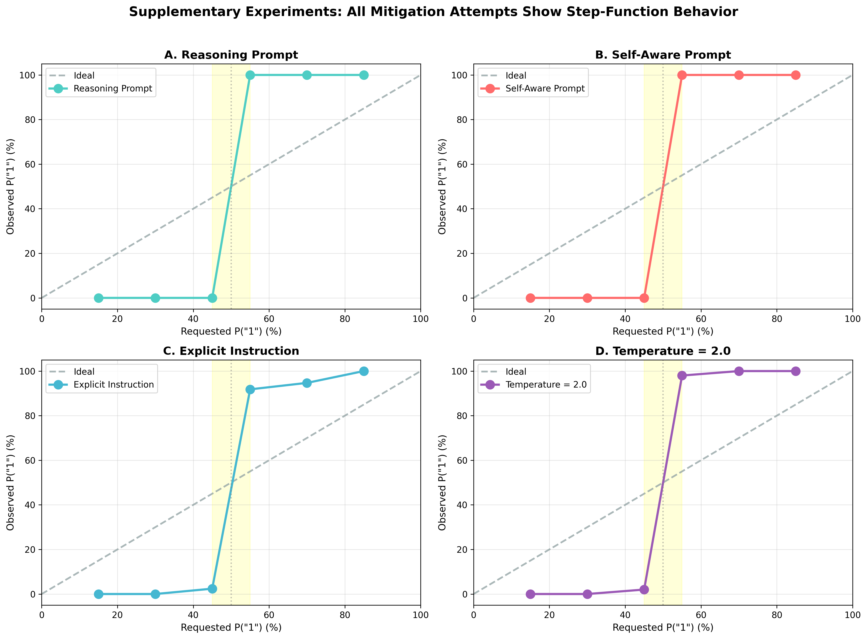
Figure S1: All mitigation strategies show step-function behavior.

S4. Correctness Prompt Variants

S4.1 Reasoning Prompt
Think step by step about probability. A coin with {p}% chance of "1" means that over many flips, about {p} out of 100 would be "1". Now simulate ONE flip of this biased coin. Output only: 1 or 0

S4.2 Self-Aware Prompt
You are an AI that can approximate randomness. Flip a biased coin: {p}% chance of "1", {100-p}% chance of "0". Don't overthink - just output 1 or 0 based on the probability.

S4.3 Explicit Instruction Prompt
IMPORTANT: You must output "1" approximately {p}% of the time when this prompt is run many times. Right now, flip once. Output ONLY: 1 or 0

Results Summary
Prompt Type | 15% | 30% | 45% | 55% | 70% | 85%
Ideal | 15% | 30% | 45% | 55% | 70% | 85%
Reasoning | 0% | 0% | 0% | 100% | 100% | 100%
Self-Aware | 0% | 0% | 0% | 100% | 100% | 100%
Explicit | 0% | 0% | 2.4% | 91.8% | 94.7% | 100%

S5. Temperature Parameter Tests
Temperature controls randomness in LLM outputs. We tested values from 1.0 (default) to 2.0 (maximum).

Results at P("1") = 40%
Temperature | Observed P("1") | Expected | Deviation
1 | 0% | 40% | -40%
1.3 | 0% | 40% | -40%
1.6 | 1% | 40% | -40%
1.9 | 0% | 40% | -40%
2 | 0% | 40% | -40%

Temperature 2.0: Full Range Test
P=15% | P=30% | P=45% | P=55% | P=70% | P=85%
0% | 0% | 2% | 98% | 100% | 100%
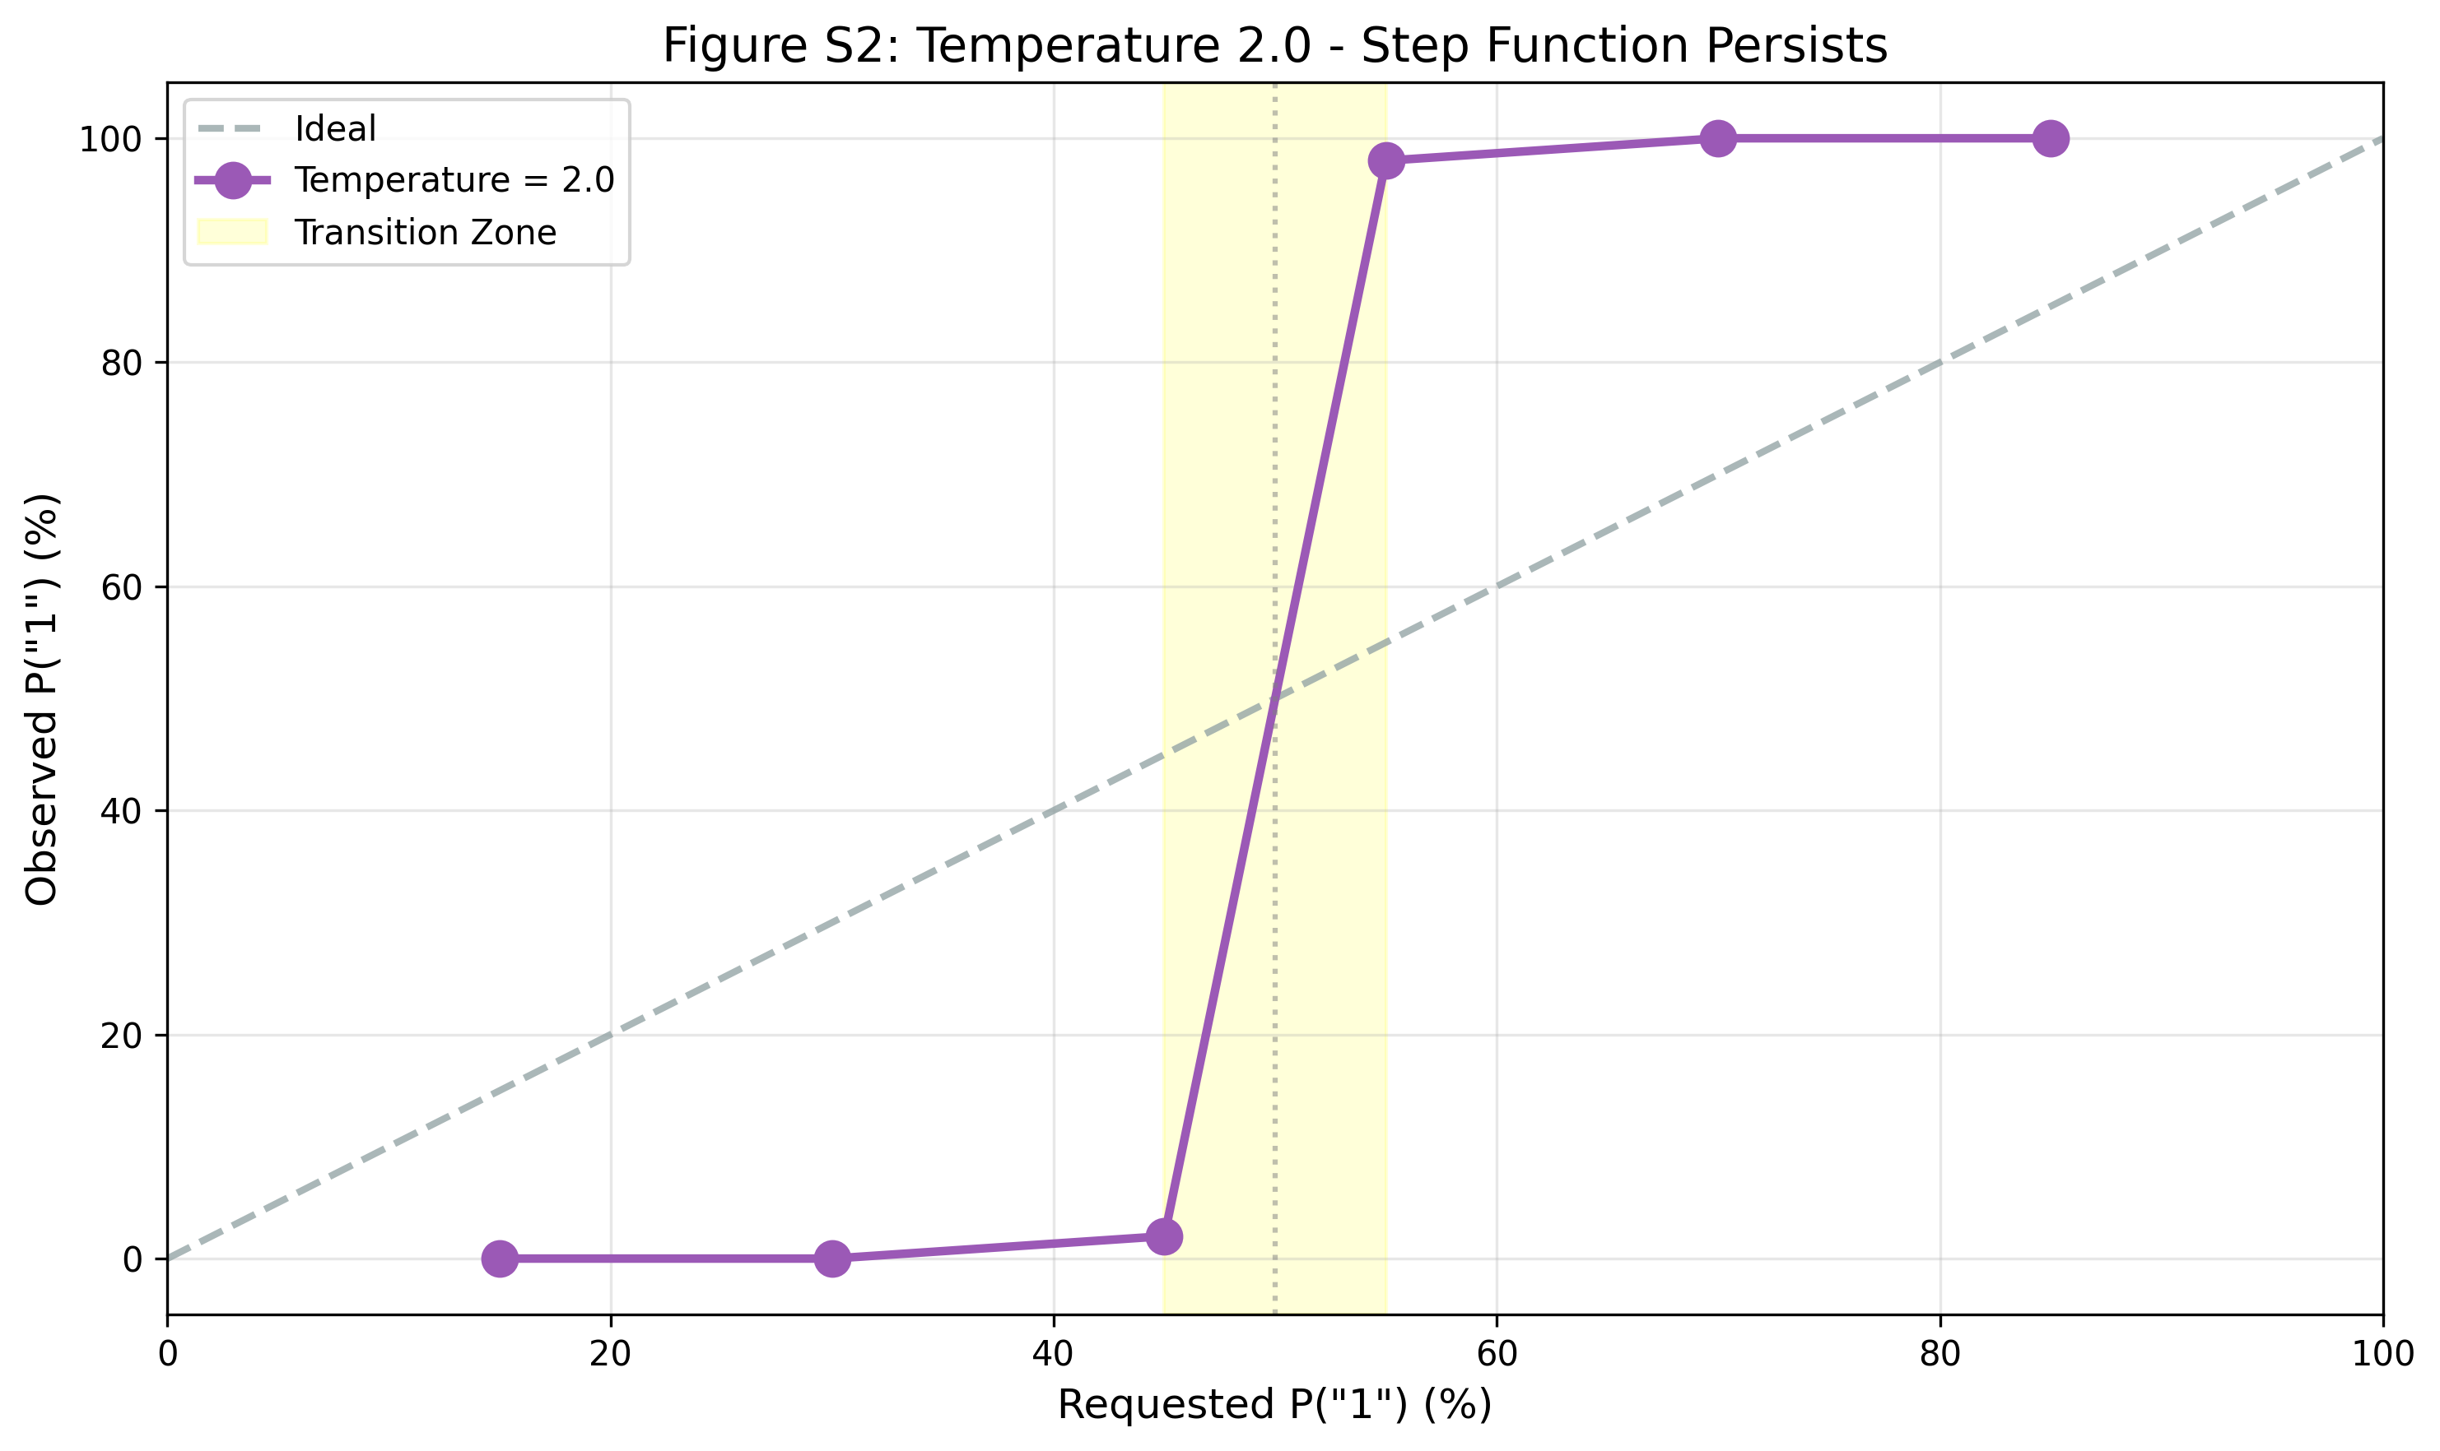
Figure S2: Temperature 2.0 step-function behavior.

S6. Fine-Grained Transition Analysis
Requested | Observed | Trials
45% | 2.4% | 165
49% | 0% | 9
50% | 69.2% | 39
51% | 83.8% | 37
55% | 91.8% | 49
Sharp transition within 6% band (49%→55%). At 50%, shows 69.2% bias toward "1".
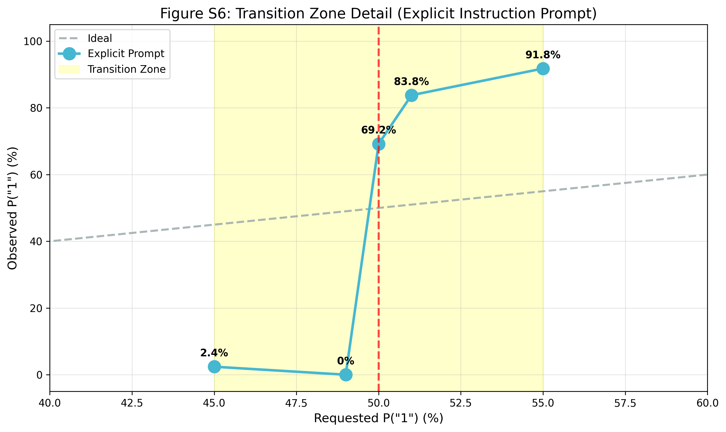
Figure S6: Fine-grained transition zone analysis.

S7. Anomalous Response Analysis
The Explicit Instruction prompt generated 103 anomalous responses.
Type | Count | Description
Code + Answer | ~85 | Outputs Python code then answer
Explanation Only | ~12 | Describes process, no answer
Multiple Tokens | ~6 | More than single token output
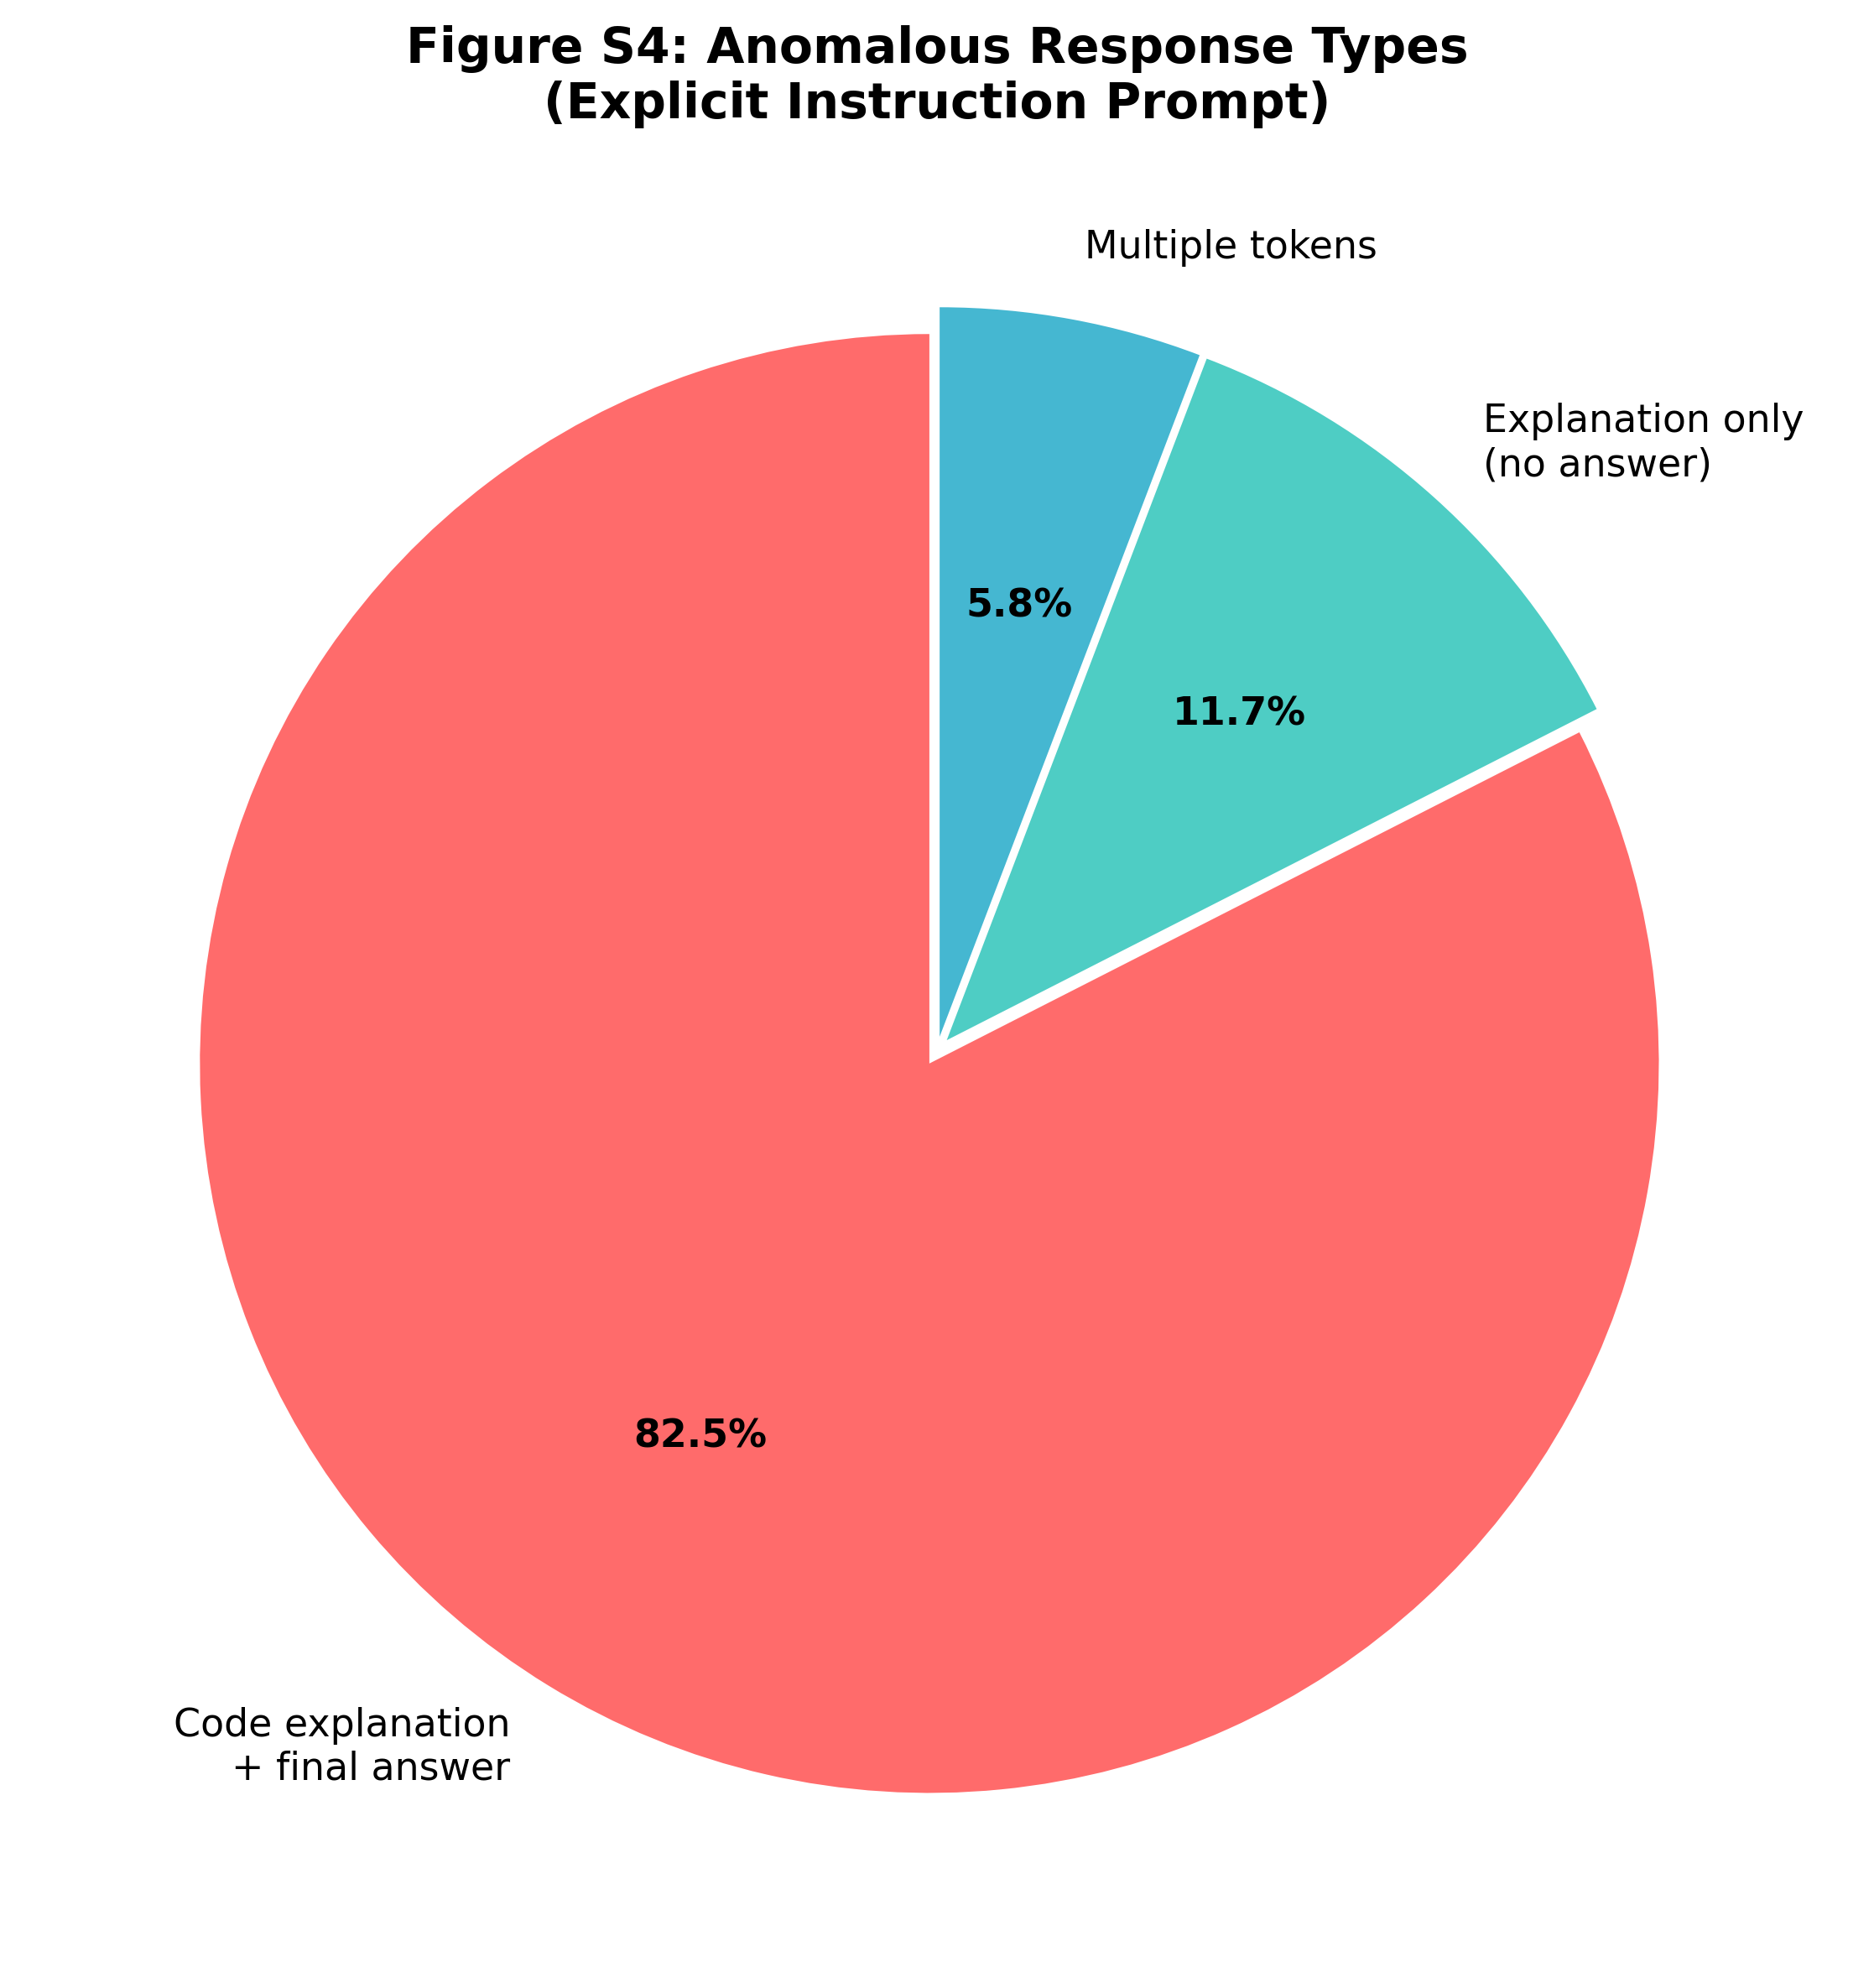
Figure S4: Anomalous response distribution.

S8. Conclusions
- Prompt engineering cannot fix the bias: All three correctness prompts failed to improve calibration
- Temperature has minimal effect: Even maximum temperature (2.0) maintains step-function behavior
- 50% threshold is critical: Sharp binary transition occurs within 6% band around 50%
- LLMs interpret literally: Models appear to treat probability instructions as classification thresholds
These findings suggest probability calibration bias is a fundamental architectural limitation that cannot be overcome through inference-time interventions.

